- Confirm Inspection Booking
  - After confirmation that your “Customs Appointed Clearing Agent” that customs declaration has been successful, “Click “Initiate Inspection Booking”, Proceed to propose the “Date and Time of Inspection”
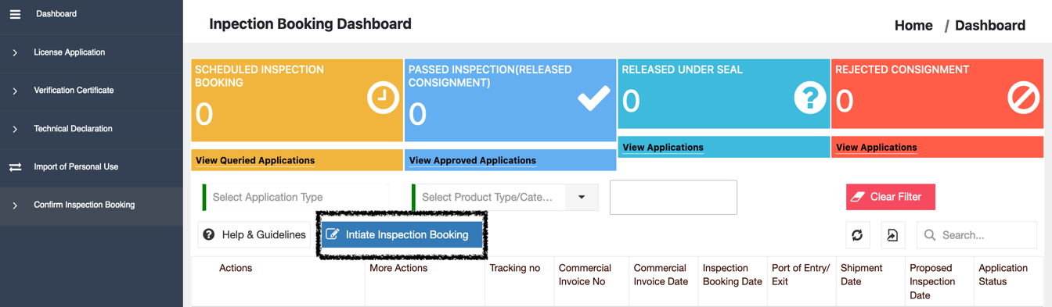
Photo 1
  - After confirming the “Technical Declaration No.” and “Customs Declaration No.”, Click “Proceed with Inspection Booking”
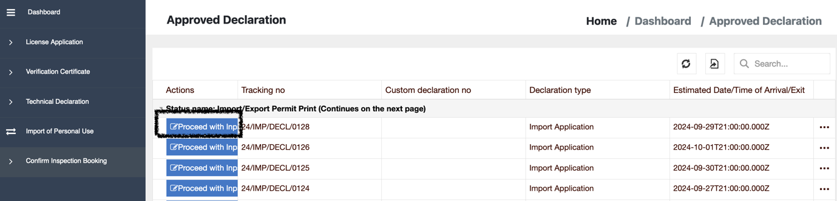
Photo 2
  - On the Step 1(“Inspection Booking Details Page”), Populate the “Location of Goods”, “Proposed Inspection Date”, “Proposed Inspection Time Slot” and “Agent Name” and click “Save and Next”
    - Location of Goods: This should be derived from Box 30 on the Customs Declaration.
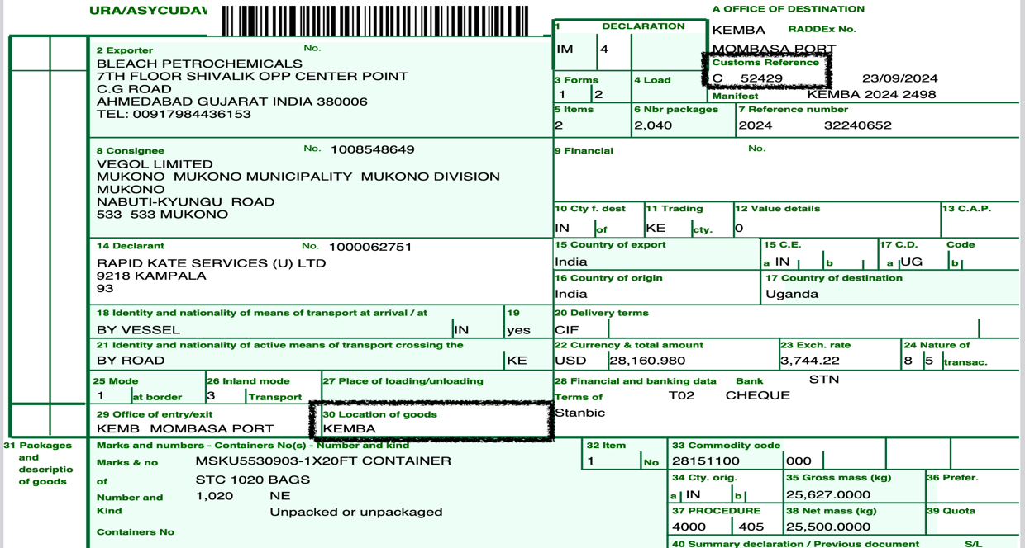
Photo 3
    - Customs Declaration Number: This is the Customs Reference on the Customs Declaration
    - Proposed Inspection Date: Propose an Inspection Date
    - Proposed Inspection Time Slot: Propose an Inspection Time
    - Agent Name: Enter the name of Agent (Individual) handling this consignment
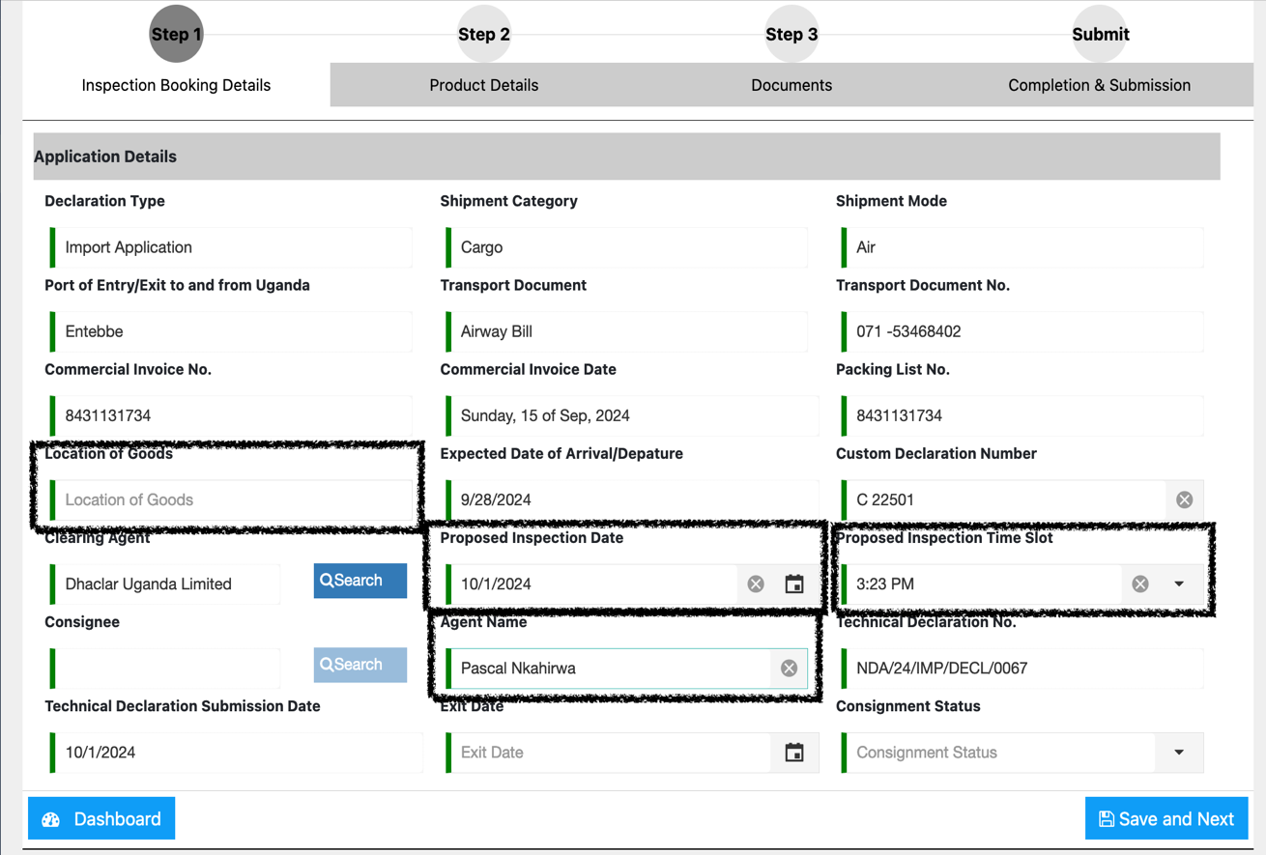
Photo 4
  - On Step 2 “Products Details Page”, review and confirm that the information is accurate
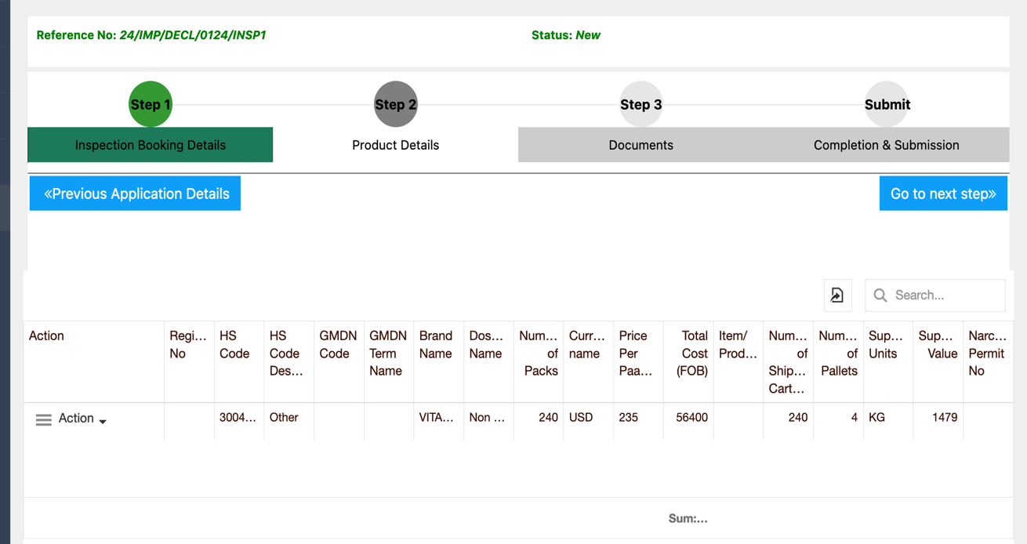
Photo 5
  - Click “Go to Next Step”, and attach the required documents
  - On Step 3 “Documents” Attach the required documents by clicking “Upload” then “Select File(s)” and finally “Upload Application Document”.
Note 1: Fill the “Description Field” if you need to provide clarification about a document attached.
Note 2: You must respect the document types prescribed e.g., PDF, JPG, JPEG, PNG
Note 3: All mandatory documents must be attached before proceeding to the next step
Note 4: Ensure that the following response(below) is reflected after submission

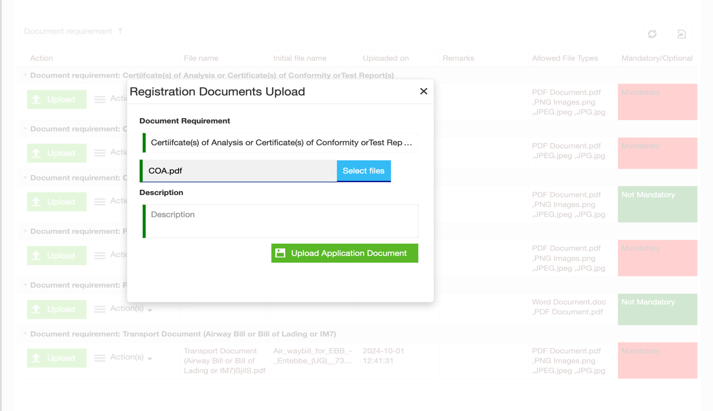
Photo 6

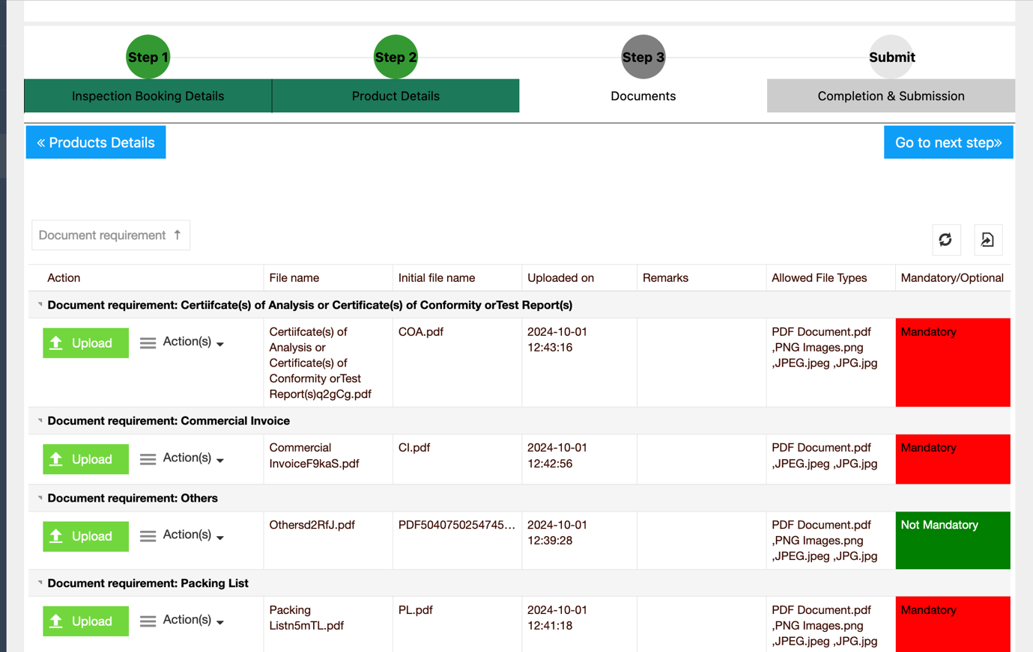
Photo 7

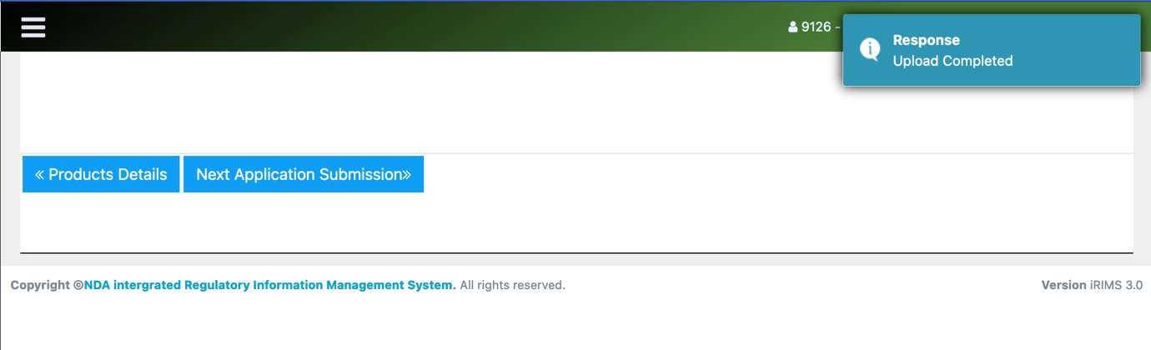
Photo 8
  - “Completion and Submission”. Click “Agree to Declaration” and “Submit Inspection Booking”
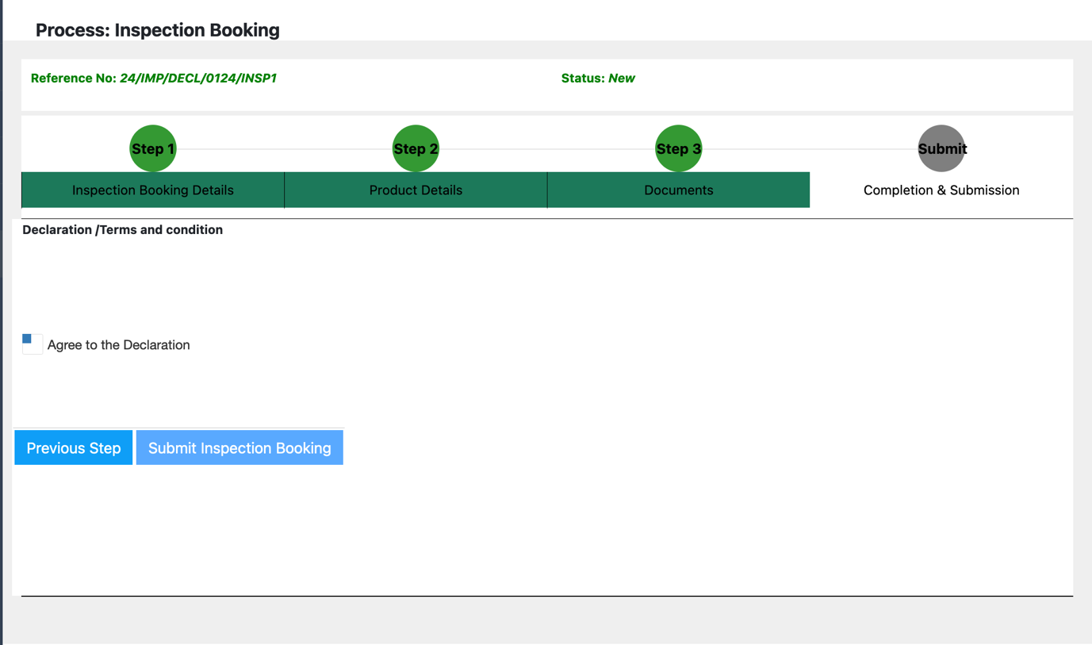
Photo 9

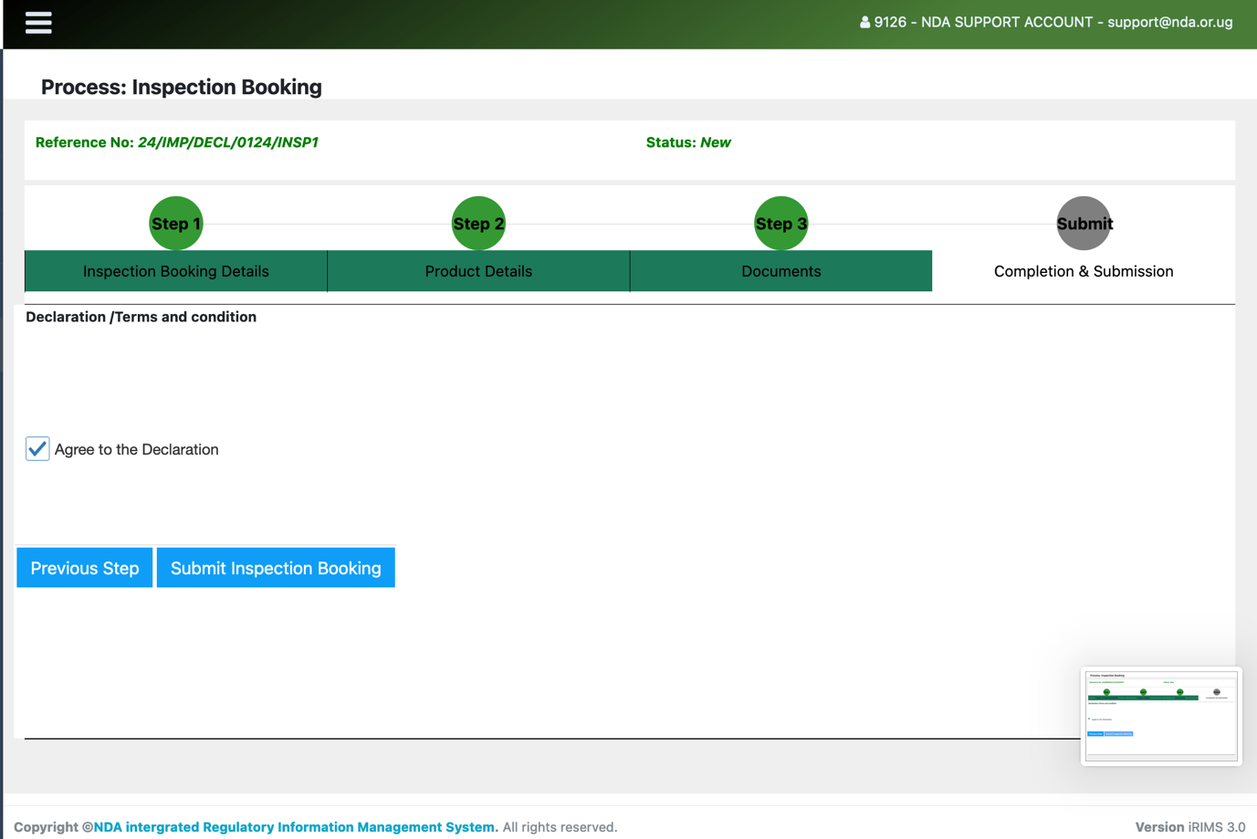
Photo 10

